Acceptance Test Procedure

Results (SKYDOC-XXXX)

For

Skyryse Flight OS LEMA TPX 325

Software Version: 1918900-0.9.4.121

|  |  |  |  |  |
| --- | --- | --- | --- | --- |
| LEMA Assembly Part Number | Operator | Condition | Serial Number | Test Start Time |
| LEMA | Shawn | Engineering | 0030 | 5/15/2023 6:10:52 PM |

|  |  |  |
| --- | --- | --- |
| **Full Test Results:** | **Fail** | |
|  | | |
| **Group** | **Pass/Fail** | |
| **6.1. Visual Examination of the Product** | Pass | |
| **6.2 Weight** | Pass | |
| 6.3 Bonding | Fail | |
| **6.4** Resistance and Inductance Test **(motor and solenoid)** | Fail | Fail |
| **6.5 Power ON UUT Checks** | Pass | |
| **6.6 Functional Check Out** | Pass | |
| **6.6.3 Holding Load Test** | Fail | Fail |
| **6.6.4 Brake Release** | Pass | |
| **6.6.5 N1 and N2 Extend Mechanical Stops and MCE Rigging** | Fail | |
| **6.6.6 N1 and N2 Stroke** | Fail | |
| **6.6.7 Performance Test – unloaded operation (one channel operation)** | Fail | |
| **6.6.8 Performance Test – Loaded Operation** | Fail | |
| **6.6.9 Backlash** | Fail | |

**6.1. Visual Examination of the Product**

|  |  |
| --- | --- |
| UUT conforms to the requirements of paragraph 6.1 | Pass |

**6.2 Weight**

|  |  |  |  |
| --- | --- | --- | --- |
| **UUT Weight** | | | |
| **Requirements** | **Results** | | |
| **UUT weight should not exceed** | **Actual Weight** | **Units** | **Pass/Fail** |
| 10 | 9 | Lbs. | Pass |

6.3 Bonding

**Bonding resistance:**

|  |  |  |  |  |  |
| --- | --- | --- | --- | --- | --- |
| **Bonding Resistance** | | | | | |
| **Requirements** | | | **Results** | | |
|  | **Expected** | **Tolerance** | **Simplex** | **Duplex** | **Units** |
| Motor End Cap | 10 | 0.5 | 1 | 5 | (mOhms) |
| Solenoid housing | 10 | 0.5 | 2 | 4 | (mOhms) |
| Encoder cover | 7.5 | 0.5 | 2 | 3 | (mOhms) |
| All Bonding Pass/Fail | | | Fail | |  |

**6.4 Resistance and Inductance Test** **(motor and solenoid)**

**Resistances:**

|  |  |  |  |  |  |  |
| --- | --- | --- | --- | --- | --- | --- |
| **Motor and Solenoid Resistances** | | | | | | |
| **Requirements** | | | **Results** | | | |
| Pins | **Expected** | **Tolerance** | **Connector J1** | **Connector J2** | **Connector J3** | **Units** |
| E to F | 0.212 | 0.0212 | 12 | 1 | 9 | (Ohms) |
| F to G | 0.212 | 0.0212 | 2 | 0 | 2 | (Ohms) |
| G to E | 0.212 | 0.0212 | 3 | 1 | 3 | (Ohms) |
| A to L | 6.55 | 0.44 | 4 | 2 | 4 | (Ohms) |
| G,F,E,A,L tied together to chassis grounds. Apply 500VDC | 5000000 | 0 | 5 | 2 | 1 | (Ohms) |
| All Resistances Pass/Fail | | | Fail | | |  |

**Inductances:**

|  |  |  |  |  |  |  |
| --- | --- | --- | --- | --- | --- | --- |
| **Motor and Solenoid Inductances** | | | | | | |
| **Requirements** | | | **Results** | | | |
|  | **Expected** | **Tolerance** | **Connector J1** | **Connector J2** | **Connector J3** | **Units** |
| E to F | 0.155 | 0.02325 | 0 | 0 | 0 | (mH) |
| F to G | 0.155 | 0.02325 | 0 | 0 | 0 | (mH) |
| G to E | 0.155 | 0.02325 | 2 | 2 | 2 | (mH) |
| A to L | 22 | 3.3 | 0 | 0 | 0 | (mH) |
| All Inductances Pass/Fail | | | Fail | | |  |

**6.5 Power ON UUT Checks**

Confirm all sensors are reporting nominal values and no faults reported

|  |  |  |  |
| --- | --- | --- | --- |
| **Power ON UUT Checks** | | | |
| **Description** | **Results** | | |
| **Sensor** | **Value** | **Units** | **Pass/Fail** |
| Motor 1 | -0.0001 | in | Pass |
| Motor 2 | -0.0030 | in | Pass |
| Motor 3 | -0.0112 | in | Pass |
| M1 | 0.0000 | in | Pass |
| M2 | 0.0000 | in | Pass |
| M3 | 0.0000 | in | Pass |
| Faults 1 | 1024 | Code | Pass |
| Faults 2 | 1024 | Code | Pass |
| Faults 3 | 1024 | Code | Pass |

**6.6 Functional Check Out**

**6.6.1 MCE1, MCE 2, MCE3 Power Up**

|  |  |  |  |  |
| --- | --- | --- | --- | --- |
| **Functional Check Out** | | | | |
| **Requirements** | **Results** | | | |
| **Description** | **Ballnut position** | **Units** | **Pass/Fail** | |
| MCE 1 reports values for Ballnut position and motor current | 0 | in | Ballnut Position | Current |
| Pass | Pass |
| (Simulated) FCC/reports values for M1(QPS) | -0 | in | Pass |  |
| MCE 2 reports values for Ballnut position and motor current | 0.0003 | in | Pass | Pass |
| (Simulated) FCC/reports values for M2(QPS) | -0 | in | Pass |  |
| MCE 3 reports values for Ballnut position and motor current | -0.0083 | in | Pass | Pass |
| (Simulated) FCC/reports values for M3(QPS) | -0 | in | Pass |  |

**6.6.3 Holding Load Test**

**6.6.3.1 Brake OFF, LEMA Output Locked**

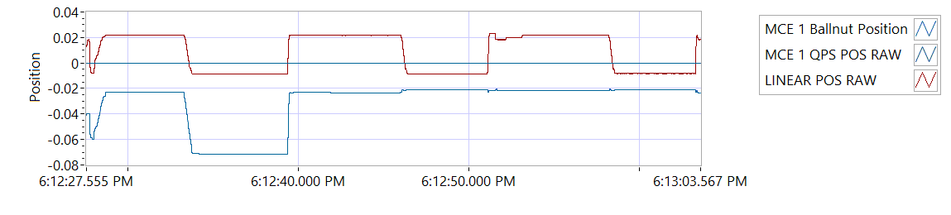

Figure -Hold Brake OFF for MCE 1

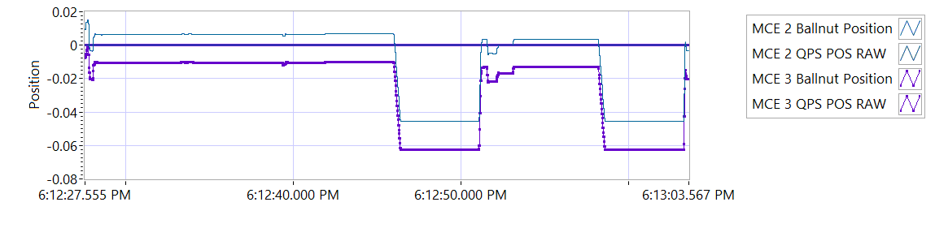

Figure -Hold Brake OFF for MCE 2

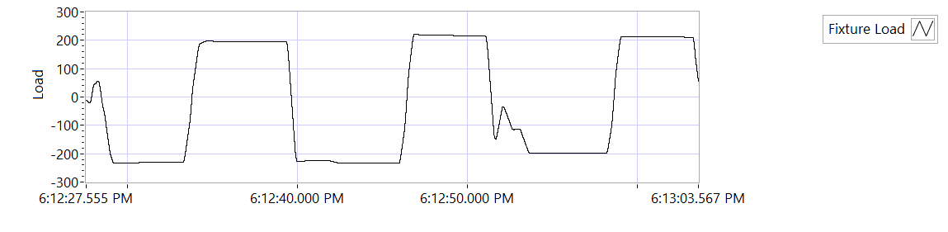

Figure -Hold Brake OFF for MCE 3

|  |  |  |  |  |  |
| --- | --- | --- | --- | --- | --- |
| **Holding Load Test - Brake OFF, LEMA Output Locked** | | | | | |
| **Requirements** | | | **Results** | | |
| **MCE** | **Expected Output Force/Amps** | **Tolerance** | **Actual Output force/Amps** | **Units** | **Output force/Amps, Pass/Fail** |
| MCE 1, 6.6.3.1.1 step d/e– extend 0.4 in, Sustain 12.6 Amps (TBC) current limit for 3-5 seconds | 562.5 | 237.5 | -230.0967 | lbf | Failed |
| 12.6 | 8.0 | 5.9991 | A | Pass |
| MCE 1, 6.6.3.1.1 step f/g - retract 0.4 in, Sustain 12.6 Amps (TBC) current limit for 3-5 seconds | 562.5 | 237.5 | 193.4135 | lbf | Failed |
| -12.6 | 8.0 | -6.0068 | A | Pass |
| MCE 2, 6.6.3.1.2 step d/e– extend 0.4 in, Sustain 12.6 Amps (TBC) current limit for 3-5 seconds | 562.5 | 237.5 | -232.3745 | lbf | Failed |
| 12.6 | 8.0 | 6.0066 | A | Pass |
| MCE 2, 6.6.3.1.2 step f/g - retract 0.4 in, Sustain 12.6 Amps (TBC) current limit for 3-5 seconds | 562.5 | 237.5 | 216.5055 | lbf | Failed |
| -12.6 | 8.0 | -5.9994 | A | Pass |
| MCE 3, 6.6.3.1.3 step d/e– extend 0.4 in, Sustain 12.6 Amps (TBC) current limit for 3-5 seconds | 562.5 | 237.5 | -195.5713 | lbf | Failed |
| 12.6 | 8.0 | 5.994 | A | Pass |
| MCE 3, 6.6.3.1.3 step f/g - retract 0.4 in, Sustain 12.6 Amps (TBC) current limit for 3-5 seconds | 562.5 | 237.5 | 211.3652 | lbf | Failed |
| -12.6 | 8.0 | -6.0063 | A | Pass |

**6.6.3.2 Brake ON, LEMA Output Free**

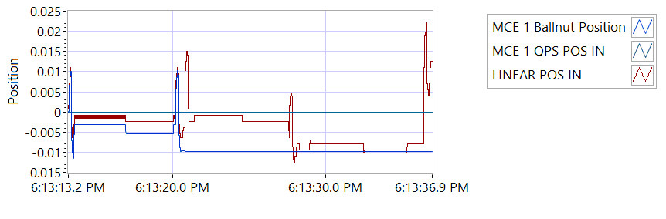

Figure -Hold Brake ON for MCE 1

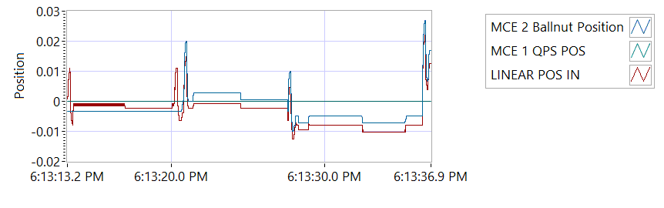

Figure -Hold Brake ON for MCE 2

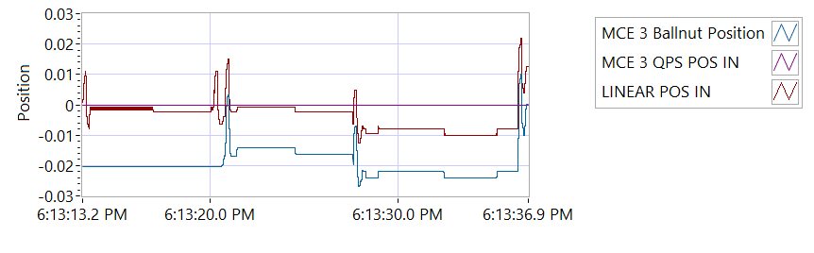

Figure -Hold Brake ON for MCE 3

|  |  |  |  |  |  |  |
| --- | --- | --- | --- | --- | --- | --- |
| **Holding Load Test - Brake ON, LEMA Output Free**  **12.6 +- 8 Amps for 3-5 sec** | | | | | | |
| **Requirements** | **Results** | | | | | |
| **MCE** | **MCE Current** | **Units** | **Current Pass/Fail** | **Position feedback** | **Units** | **Position Feedback Pass/Fail** |
| MCE 1, 6.6.3.2.1 step I – extend 0.4 in | 6.0005 | A | Pass | -0.0016 | in | Pass |
| MCE 1, 6.6.3.2.1 step k - retract 0.4 in | -6.0049 | A | True | -0.0024 | in | Pass |
| MCE 2, 6.6.3.2.2 step i – extend 0.4 in | 6.009 | A | True | -0.0008 | in | Pass |
| MCE 2, 6.6.3.2.2 step k - retract 0.4 in | -6.0088 | A | True | -0.0024 | in | Pass |
| MCE 3, 6.6.3.2.3 step I – extend 0.4 in | 5.9945 | A | True | -0.0079 | in | Pass |
| MCE 3, 6.6.3.2.3 step k - retract 0.4 in | -5.9992 | A | True | -0.0102 | in | Pass |

**6.6.4 Brake Release Test**

**Step d –** LEMA reaches commanded position.

|  |  |  |  |  |  |
| --- | --- | --- | --- | --- | --- |
| **Brake Release Test** | | | | | |
| **Requirements** | | | **Results** | | |
| Description | Expected | Tolerance | Position | Units | Pass/Fail |
| MCE1 /Motor 1 | 0.4 | 0.05 | 0.400 | in | Pass |
| MCE2 /Motor 2 | 0.4 | 0.05 | 0.400 | in | Pass |
| MCE3 /Motor 3 | 0.4 | 0.05 | 0.400 | in | Pass |

**6.6.5 N1 and N2 Extend Mechanical Stops and MCE Rigging**

**Step 6.6.5.1** **Extend using M1/N1**

|  |  |  |  |
| --- | --- | --- | --- |
| **Extend using M1/N1** | | | |
| **Requirements** | **Results** | | |
| **Description** | **Value** | **Units** | **Pass/Fail** |
| N1 extend stop engaged (M1 current saturated) | 1024 | Code | Pass |
| MCE 1 Motor Current 4.5 +/- 0.15 Amps | 5.9933 | Amps | Failed |
| Linear Encoder Value | 0.0944 | in | Pass |
| N1 is Rigged | 0 | Code | Pass |

**Step 6.6.5.2** **Extend using M2/N2**

|  |  |  |  |
| --- | --- | --- | --- |
| **Extend using M2/N2** | | | |
| **Requirements** | **Results** | | |
| **Description** | **Value** | **Units** | **Pass/Fail** |
| N2 extend stop engaged (M2 current saturated) | 1024 | Code | Pass |
| MCE2 Motor Current 4.5 +/- 0.15 Amps | 6.0011 | Amps | Failed |
| Linear Encoder Value | 0.0496 | in | Pass |
| N2 (Motor 2) is Rigged | 0 | Code | Pass |
| N2 (Motor 3) is Rigged | 0 | Code | Pass |

**6.6.6 N1 and N2 Stroke Check**

|  |  |  |  |  |  |
| --- | --- | --- | --- | --- | --- |
| **N1 and N2 Stroke Check Position** | | | | | |
| **Requirements** | | | **Results** | | |
| **Pin to pin Length** | **Expected** | **Tolerance** | **Pin to Pin Length** | **Units** | **Pass/Fail** |
| 16.732 | 1 | 16.3 | in | Pass |
| **Requirements** | | | **Results** | | |
| **Description** | **Expected** | **Tolerance** | **Actual Position N1/N2** |  | **Pass/Fail** |
| N2 at -0.575 ins from Null using M2 | -0.575 | 0.1 | -0.575 | in | Pass |
| N1 at +1.725 ins from Null using M1 | 1.725 | 0.1 | 1.725 | in | Pass |
| N1 at -0.575 ins from Null using M1 | -0.575 | 0.1 | -0.5752 | in | Pass |
| N2 at +1.725 ins from NULL using M2 | 1.725 | 0.1 | 1.725 | in | Pass |
| N1 at -0.575 ins from Null using M1 | -0.575 | 0.1 | -0.575 | in | Pass |
| N2 at +1.725 ins from Null using M3 | 1.725 | 0.1 | 1.7251 | in | Pass |
| N2 at -0.575 ins from Null using M3 | -0.575 | 0.1 | -0.5743 | in | Pass |

|  |  |  |  |  |  |
| --- | --- | --- | --- | --- | --- |
| **All Motor Stroke Check Description** | | | | | |
| **Requirements** | | | **Results** | | |
| **Description** | **Expected Difference from Test rig encoder** | **Tolerance** | **Difference from Test rig encoder** | **Units** | **Pass/Fail** |
| Motor 1 position + Motor 2 position = test rig encoder | 0 | 0.1 | 0.0103 | in | Pass |
| Motor1 position + Motor 3 position = test rig encoder | 0 | 0.1 | 0.0103 | in | Pass |
| M1 position + M2 position = test rig encoder | 0.1 | 0.1 | -0.3631 | in | Failed |
| M1 position + M3 position = test rig encoder | 0 | 0.1 | -0.3631 | in | Failed |
| Difference between Motor 2 position and Motor 3 position is < TBD ins | 0 | 0.1 | 0 | in | Pass |
| Difference between M2 position and M3 position is < TBD ins | 0 | 0 | 0 | in | Pass |
| Difference between Motor 1 position and M1 position is < TBD ins | 0 | 0.1 | 0.9484 | in | Failed |
| Difference between Motor 2 position and M2 position is < TBD ins | 0 | 0.1 | 0.575 | in | Failed |
| Difference between Motor 3 position and M3 position is < TBD ins | 0 | 0.1 | 0.575 | in | Failed |

MOTOR 1

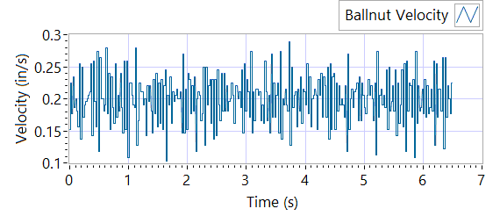

Figure - Ballnut Velocity for Motor One

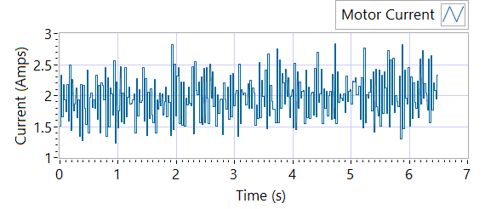

Figure -Current for Motor One

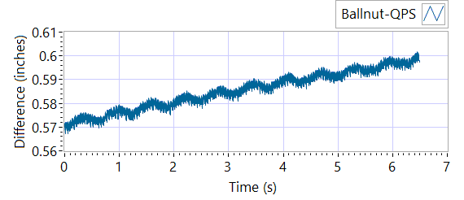

Figure - M1 Delta for Motor One

|  |  |  |  |  |  |  |
| --- | --- | --- | --- | --- | --- | --- |
| **MOTOR 1 STROKE CHECK** | | | | | | |
| **Requirements** | | | **Results** | | | |
| **Description** | **Expected** | **Tolerance** | **Actual Average** | **Peak Velocity** | **Units** | **Pass/Fail** |
| Constant Velocity | 0.2 | 0.02 | 0.1997 | 0.1997 | In/s | Pass |
| **Description** | **Expected** | **Tolerance** | **Actual** | **Standard Deviation** | **Units** | **Pass/Fail** |
| Delta between Motor 1 Position and M1 position | 0.1 | 0.2 | 1.5953 | 0.008 | in | Failed |
| Delta between Motor 1 Position and Linear Encoder position | 0.1 | 0.2 | 0.6018 | 0.3748 | in | Failed |
| Motor Current |  |  | 1.9732 | 0.3498 | Amps |  |

MOTOR 2

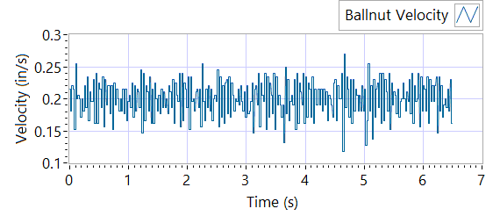

Figure - Ballnut Velocity for Motor Two

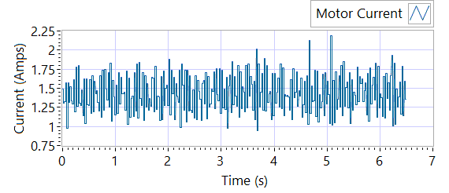

Figure -Current for Motor Two

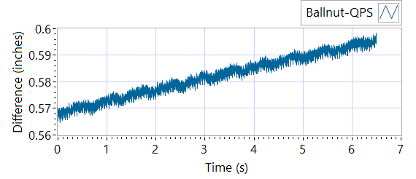

Figure - M1 Delta for Motor Two

|  |  |  |  |  |  |  |
| --- | --- | --- | --- | --- | --- | --- |
| **MOTOR 2 STROKE CHECK** | | | | | | |
| **Requirements** | | | **Results** | | | |
| **Description** | **Expected** | **Tolerance** | **Actual Average** | **Peak Velocity** | **Units** | **Pass/Fail** |
| Constant Velocity | 0.2 | 0.02 | 0.2001 | 0.2001 | In/s | Pass |
| **Description** | **Expected** | **Tolerance** | **Actual** | **Standard Deviation** | **Units** | **Pass/Fail** |
| Delta between Motor 2 Position and M2 position | 0.1 | 0.2 | 1.5972 | 0.008 | Inches | Failed |
| Delta between Motor 2 Position and Linear Encoder position | 0.1 | 0.2 | 0.5985 | 0.3747 | Inches | Failed |
| Motor Current |  |  | 1.4327 | 0.2491 | Amps |  |

MOTOR 3

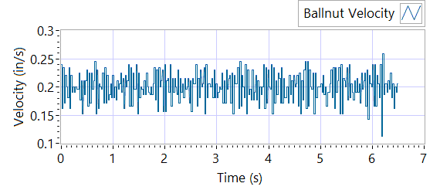

Figure - Ballnut Velocity for Motor Three

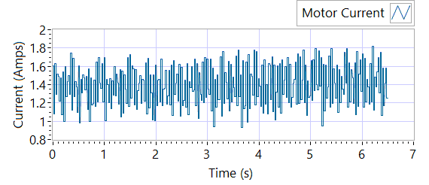

Figure -Current for Motor Three



Figure - M3 Delta for Motor Three

|  |  |  |  |  |  |  |
| --- | --- | --- | --- | --- | --- | --- |
| **MOTOR 3 STROKE CHECK** | | | | | | |
| **Requirements** | | | **Results** | | | |
| **Description** | **Expected** | **Tolerance** | **Actual Average** | **Peak Velocity** | **Units** | **Pass/Fail** |
| Constant Velocity | 0.2 | 0.02 | 0.2001 | 0.2001 | In/s | Pass |
| **Description** | **Expected** | **Tolerance** | **Actual** | **Standard Deviation** | **Units** | **Pass/Fail** |
| Delta between Motor 3 Position and M3 position | 0.1 | 0.2 | 1.5859 | 0.008 | in | Failed |
| Delta between Motor 3 Position and Linear Encoder position | 0.1 | 0.2 | 0.5982 | 0.3753 | in | Failed |
| Motor Current |  |  | 1.3938 | 0.2222 | Amps |  |

**6.6.7 Performance Test – unloaded operation (one channel operation)**

**6.6.7.1.1 MCE 1 - Step Response Test**

**The result for motor one is shown below:**

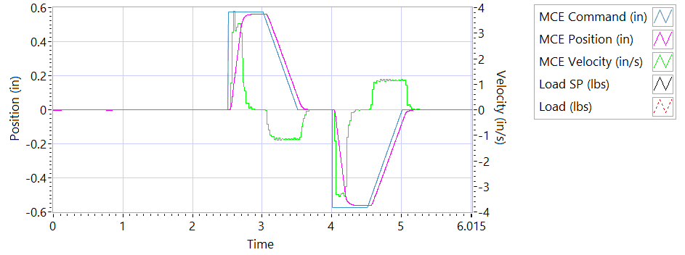

Figure - Results for Motor One

**Step d Extension**

|  |  |  |  |
| --- | --- | --- | --- |
| **MCE 1 - Step Response Extension Unloaded** | | | |
| **Requirements** | **Results** | | |
| **Description** | **Actual Speed / Time** | **Units** | **Pass/Fail** |
| No Load speed is 2.7 to 3.3 in/sec | 3.2436 | In/s | True |
| Time to achieve 80% of the specified stroke (+ 0.575 ins) is 170+9/-9 ms | 0.2 | seconds | Failed |

**Step e Retraction**

|  |  |  |  |
| --- | --- | --- | --- |
| **MCE 1 - Step Response Retraction Unloaded** | | | |
| **Requirements** | **Results** | | |
| **Description** | **Actual Speed / Time** | **Units** | **Pass/Fail** |
| No Load speed is 2.7 to 3.3 in/sec | -3.2527 | In/s | True |
| Time to achieve 80% of the specified stroke (- 0.575 ins) is 170+9/-9 ms | 0.1956 | seconds | Failed |

**6.6.7..1.2 MCE 1 - Frequency Response**

**Step d**

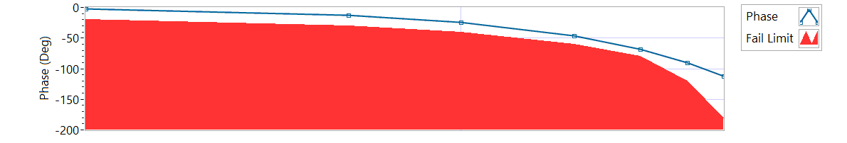

Figure - Phase for Motor One

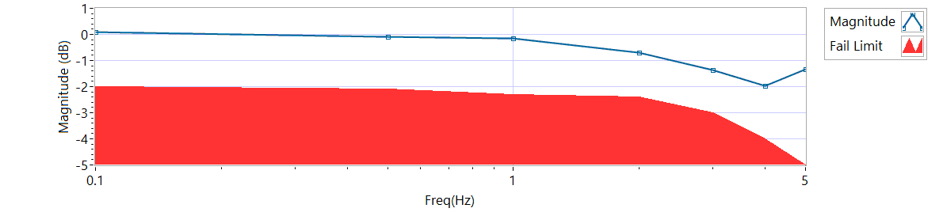

Figure - Magnitude for Motor One

**Frequency Response**

|  |  |  |  |  |
| --- | --- | --- | --- | --- |
| **MCE 1 - Frequency Response Unloaded** | | | | |
| **Frequency**  **(Hz)** | **Magnitude**  **(dB)** | **Phase**  **(deg)** | **Max Phase**  **Allowance (deg)** | **Pass/Fail** |
| 0.1 Hz | 0.0772562 | -2.0844 | -20 | Pass |
| 0.5 Hz | -0.0868924 | -12.24 | -30 | Pass |
| 1 Hz | -0.156214 | -23.832 | -40 | Pass |
| 2 Hz | -0.701952 | -46.512 | -60 | Pass |
| 3 Hz | -1.36381 | -68.688 | -80 | Pass |
| 4 Hz | -1.9576 | -90.144 | -120 | Pass |
| 5 Hz | -1.32779 | -112.32 | -180 | Pass |

6.6.7.2.1 **MCE 2 - Step Response Test**

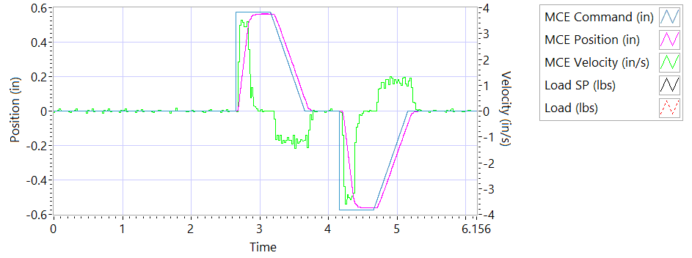

Figure - Results for Motor Two

**Step d Extension**

|  |  |  |  |
| --- | --- | --- | --- |
| **MCE 2 - Step Response Extension Unloaded** | | | |
| **Requirements** | **Results** | | |
| **Description** | **Actual Speed / Time** | **Units** | **Pass/Fail** |
| No Load speed is 2.7 to 3.3 in/sec | 3.2751 | In/s | Pass |
| Time to achieve 80% of the specified stroke (+ 0.575 ins) is 170+9/-9 ms | 0.1895 | seconds | Failed |

**Step e Retraction**

|  |  |  |  |
| --- | --- | --- | --- |
| **MCE 2 - Step Response Retraction Unloaded** | | | |
| **Requirements** | **Results** | | |
| **Description** | **Actual Speed / Time** | **Units** | **Pass/Fail** |
| No Load speed is 2.7 to 3.3 in/sec | -3.2812 | In/s | Pass |
| Time to achieve 80% of the specified stroke (- 0.575 ins) is 170+9/-9 ms | 0.2193 | seconds | Failed |

6.6.7.2.2 **MCE 2 - Frequency Response Test**

**Step d**

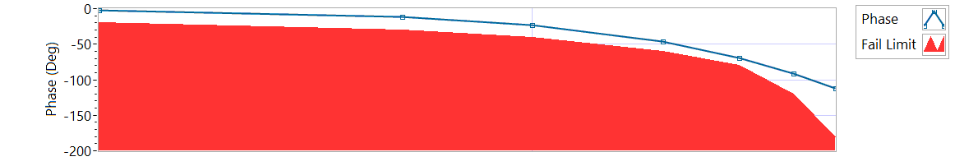

Figure - Phase for Motor Two

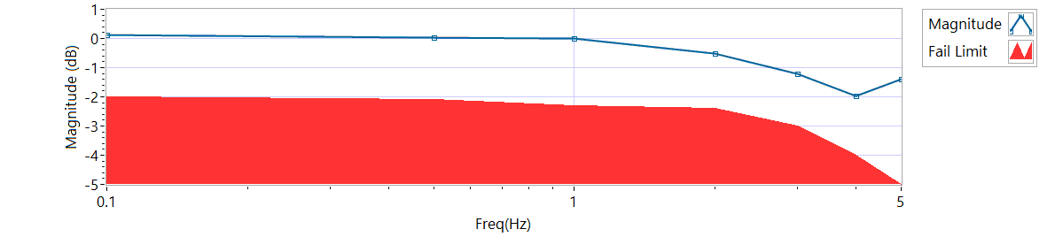

Figure - Magnitude for Motor Two

**Frequency Response**

|  |  |  |  |  |
| --- | --- | --- | --- | --- |
| **MCE 2 - Frequency Response Unloaded** | | | | |
| **Frequency (Hz)** | **Magnitude**  **(db)** | **Phase**  **(Deg)** | **Max Phase**  **Allowance (Deg)** | **Pass/Fail** |
| 0.1 Hz | 0.131287 | -2.0052 | -20 | Pass |
| 0.5 Hz | 0.0365077 | -11.916 | -30 | Pass |
| 1 Hz | -0.00443087 | -23.58 | -40 | Pass |
| 2 Hz | -0.52588 | -46.296 | -60 | Pass |
| 3 Hz | -1.20531 | -69.552 | -80 | Pass |
| 4 Hz | -1.95528 | -91.152 | -120 | Pass |
| 5 Hz | -1.38237 | -112.68 | -180 | Pass |

6.6.7.3.1 **MCE 3 – Step Response Test**

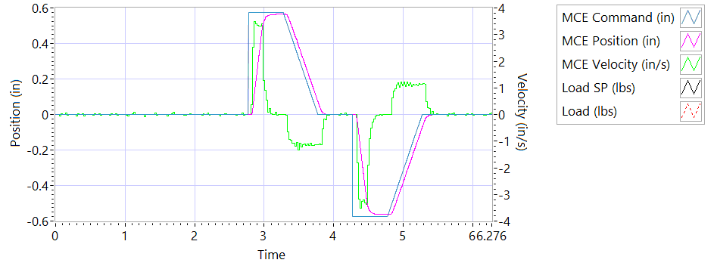

Figure - Results for Motor Three

**Step d Extension**

|  |  |  |  |
| --- | --- | --- | --- |
| **MCE 3 – Step Response Extension Unloaded** | | | |
| **Requirements** | **Results** | | |
| **Description** | **Actual Speed / Time** | **Units** | **Pass/Fail** |
| No Load speed is 2.7 to 3.3 in/sec | 3.2751 | In/s | Pass |
| Time to achieve 80% of the specified stroke (+ 0.575 ins) is 170+9/-9 ms | 0.2151 | seconds | Failed |

**Step e Retraction**

|  |  |  |  |
| --- | --- | --- | --- |
| **MCE 3 – Step Response Retraction Unloaded** | | | |
| **Requirements** | **Results** | | |
| **Description** | **Actual Speed / Time** | **Units** | **Pass/Fail** |
| No Load speed is 2.7 to 3.3 in/sec | -3.2851 | In/s | Pass |
| Time to achieve 80% of the specified stroke (- 0.575 ins) is 170+9/-9 ms | 0.2176 | seconds | Failed |

6.6.7.3.2 **MCE 3 Frequency Response Test**

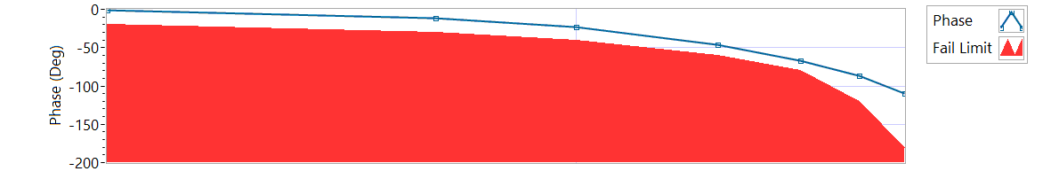

Figure - Phase for Motor Three

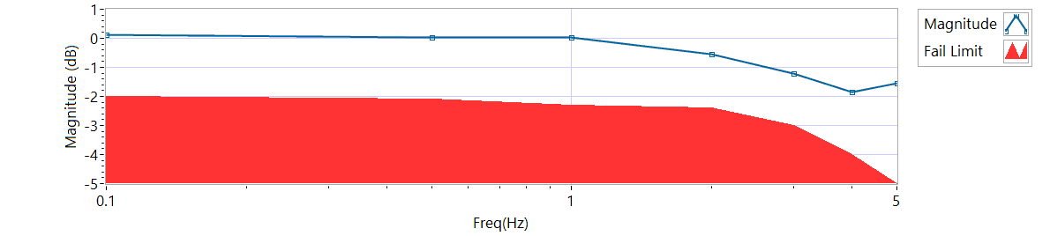

Figure - Magnitude for Motor Three

**Step d**

|  |  |  |  |  |
| --- | --- | --- | --- | --- |
| **MCE 3 Frequency Response Unloaded** | | | | |
| **Frequency**  **(Hz)** | **Magnitude**  **(dB)** | **Phase**  **(Deg)** | **Max Phase**  **Allowance (Deg)** | **Pass/Fail** |
| 0.1 Hz | 0.131287 | -1.4976 | -20 | Pass |
| 0.5 Hz | 0.0228829 | -11.268 | -30 | Pass |
| 1 Hz | 0.0228829 | -22.68 | -40 | Pass |
| 2 Hz | -0.540417 | -46.008 | -60 | Pass |
| 3 Hz | -1.22103 | -66.96 | -80 | Pass |
| 4 Hz | -1.84619 | -86.976 | -120 | Pass |
| 5 Hz | -1.54948 | -109.62 | -180 | Pass |

**6.6.8 Performance Test – Loaded Operation**

**6.6.8.1 Step and Frequency Response Test - Loaded**

**6.6.8.1.1 MCE1 – Step Response Test**

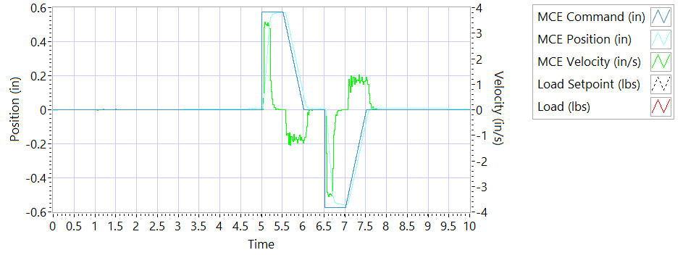

Figure - Results for Motor One Loaded

Step response Test

**Step j – 225 lbf tension - Extension**

|  |  |  |  |
| --- | --- | --- | --- |
| **MCE1 – Step Response Tension Extension** | | | |
| **Requirements** | **Results** | | |
| **Description** | **Actual Speed / Time** | **Units** | **Pass/Fail** |
| No Load speed is 2.7 to 3.3 in/sec | 3.2386 | In/s | Pass |
| Time to achieve 80% of the specified stroke (+ 0.575 ins) is 170+9/-9 ms | 0.1883 | seconds | Failed |

**Step k – 225 lbf tension - Retraction**

|  |  |  |  |
| --- | --- | --- | --- |
| **MCE1 – Step Response Tension Retraction** | | | |
| **Requirements** | **Results** | | |
| **Description** | **Actual Speed / Time** | **Units** | **Pass/Fail** |
| No Load speed is 2.7 to 3.3 in/sec | -3.2855 | In/s | Pass |
| Time to achieve 80% of the specified stroke (- 0.575 ins) is 170+9/-9 ms | 0.1992 | seconds | Failed |

**Step n – 225 lbf compression - Extension**

|  |  |  |  |
| --- | --- | --- | --- |
| **MCE1 – Step Response Compression Extension** | | | |
| **Requirements** | **Results** | | |
| **Description** | **Actual Speed / Time** | **Units** | **Pass/Fail** |
| No Load speed is 2.7 to 3.3 in/sec | 3.2076 | In/s | Pass |
| Time to achieve 80% of the specified stroke (+0.575 ins) is 170+9/-9 ms | 0.2213 | seconds | Failed |

**Step o – 225 lbf compression - Retraction**

|  |  |  |  |
| --- | --- | --- | --- |
| **MCE1 – Step Response Compression Retraction** | | | |
| **Requirements** | **Results** | | |
| **Description** | **Actual Speed / Time** | **Units** | **Pass/Fail** |
| No Load speed is 2.7 to 3.3 in/sec | -3.2088 | In/s | Pass |
| Time to achieve 80% of the specified stroke (-0.575 ins) is 170+9/-9 ms | 0.2117 | seconds | Failed |

**6.6.8.1.2 MCE 1 – Frequency Response Test**

**Step d – 225 lbf Tension**

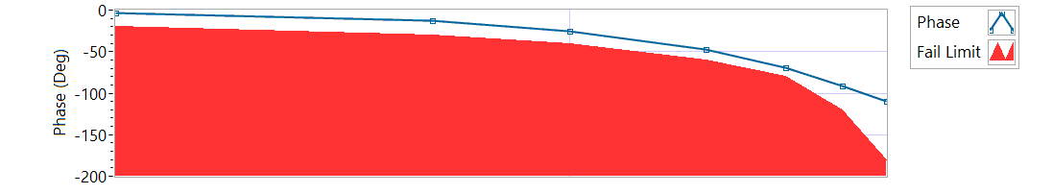

Figure - Phase for Motor One Loaded Tension

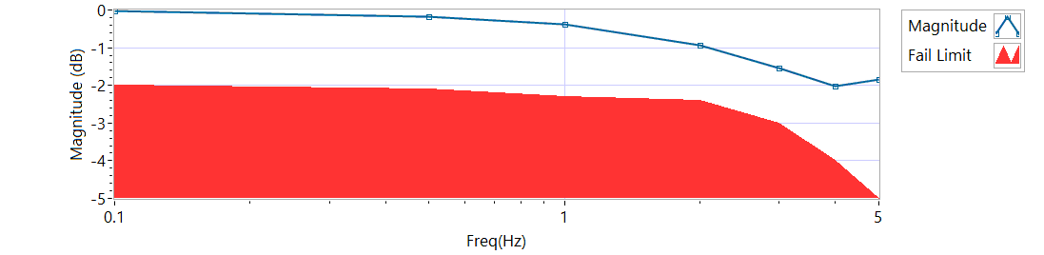

Figure - Magnitude for Motor One Loaded Tension

|  |  |  |  |  |
| --- | --- | --- | --- | --- |
| **MCE 1 – Tension Frequency Response** | | | | |
| **Frequency**  **(Hz)** | **Magnitude**  **(dB)** | **Phase**  **(Deg)** | **Max Phase**  **Allowance (Deg)** | **Pass/Fail** |
| 0.1 HZ | -0.01812 | -3.024 | -20 | Pass |
| 0.5 HZ | -0.184096 | -12.762 | -30 | Pass |
| 1 HZ | -0.381834 | -24.984 | -40 | Pass |
| 2 HZ | -0.927182 | -47.16 | -60 | Pass |
| 3 HZ | -1.54158 | -69.876 | -80 | Pass |
| 4 HZ | -2.01613 | -91.872 | -120 | Pass |
| 5 HZ | -1.84488 | -109.98 | -180 | Pass |

**Step h – 225 lbf Compression**

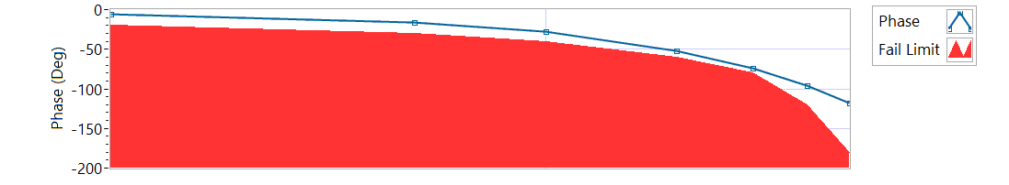

Figure - Phase for Motor One Loaded Compression

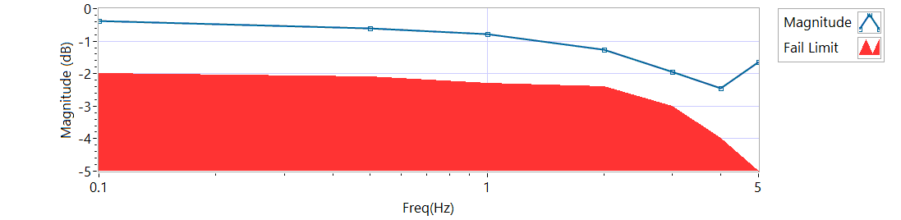

Figure - Magnitude for Motor One Loaded Compression

|  |  |  |  |  |
| --- | --- | --- | --- | --- |
| **MCE 1 – Compression Frequency Response** | | | | |
| **Frequency**  **(Hz)** | **Magnitude**  **(dB)** | **Phase**  **(Deg)** | **Max Phase**  **Allowance (Deg)** | **Pass/Fail** |
| 0.1 HZ | -0.381834 | -5.3208 | -20 | Pass |
| 0.5 HZ | -0.613472 | -16.074 | -30 | Pass |
| 1 HZ | -0.791345 | -28.188 | -40 | Pass |
| 2 HZ | -1.26846 | -51.48 | -60 | Pass |
| 3 HZ | -1.94253 | -73.872 | -80 | Pass |
| 4 HZ | -2.43752 | -95.76 | -120 | Pass |
| 5 HZ | -1.63668 | -118.08 | -180 | Pass |

**6.6.8.2.1 MCE 2 – Step Response Test**

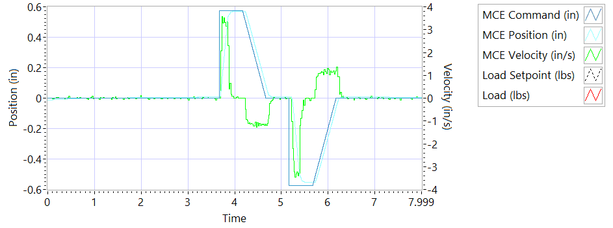

Figure - Results for Motor Two Loaded Tension

**Step j – 225 lbf tension - Extension**

|  |  |  |  |
| --- | --- | --- | --- |
| **MCE2 – Step Response Tension Extension** | | | |
| **Requirements** | **Results** | | |
| **Description** | **Actual Speed / Time** | **Units** | **Pass/Fail** |
| No Load speed is 2.7 to 3.3 in/sec | 3.2556 | In/s | Pass |
| Time to achieve 80% of the specified stroke (+ 0.575 ins) is 170+9/-9 ms | 0.1924 | seconds | Failed |

**Step k – 225 lbf tension - Retraction**

|  |  |  |  |
| --- | --- | --- | --- |
| **MCE2 – Step Response Tension Retraction** | | | |
| **Requirements** | **Results** | | |
| **Description** | **Actual Speed / Time** | **Units** | **Pass/Fail** |
| No Load speed is 2.7 to 3.3 in/sec | -3.2931 | In/s | Pass |
| Time to achieve 80% of the specified stroke (- 0.575 ins) is 170+9/-9 ms | 0.2275 | seconds | Failed |

**Step n – 225 lbf compression - Extension**

|  |  |  |  |
| --- | --- | --- | --- |
| **MCE2 – Step Response Compression Extension** | | | |
| **Requirements** | **Results** | | |
| **Description** | **Actual Speed / Time** | **Units** | **Pass/Fail** |
| No Load speed is 2.7 to 3.3 in/sec | 3.2559 | In/s | Pass |
| Time to achieve 80% of the specified stroke (+0.575 ins) is 170+9/-9 ms | 0.2247 | seconds | Failed |

**Step o – 225 lbf compression - Retraction**

|  |  |  |  |
| --- | --- | --- | --- |
| **MCE2 – Step Response Compression Retraction** | | | |
| **Requirements** | **Results** | | |
| **Description** | **Actual Speed / Time** | **Units** | **Pass/Fail** |
| No Load speed is 2.7 to 3.3 in/sec | -3.2369 | In/s | Pass |
| Time to achieve 80% of the specified stroke (-0.575 ins) is 170+9/-9 ms | 0.213 | seconds | Failed |

**6.6.8.2.2 MCE 2 – Frequency response Test**

**Step d – 225 lbf Tension**

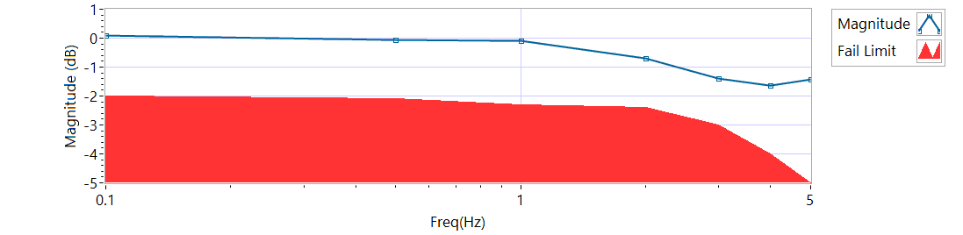

Figure - Magnitude for Motor Two Loaded Tension

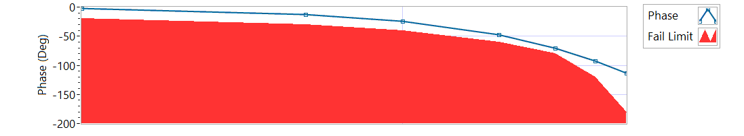

Figure - Phase for Motor Two Loaded Tension

|  |  |  |  |  |
| --- | --- | --- | --- | --- |
| **MCE 2 – Frequency response Tension** | | | | |
| **Frequency**  **(Hz)** | **Magnitude**  **(dB)** | **Phase**  **(Deg)** | **Max Phase**  **Allowance (Deg)** | **Pass/Fail** |
| 0.1 HZ | 0.0772567 | -1.836 | -20 | Pass |
| 0.5 HZ | -0.0730961 | -12.204 | -30 | Pass |
| 1 HZ | -0.100714 | -24.336 | -40 | Pass |
| 2 HZ | -0.701952 | -47.16 | -60 | Pass |
| 3 HZ | -1.37982 | -69.984 | -80 | Pass |
| 4 HZ | -1.64459 | -92.304 | -120 | Pass |
| 5 HZ | -1.43478 | -112.86 | -180 | Pass |

**Step h – 225 lbf Compression**

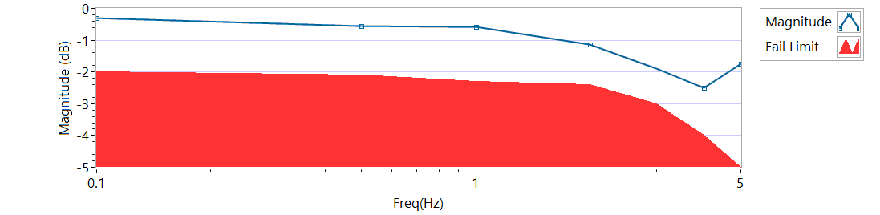

Figure - Magnitude for Motor Two Loaded Compression

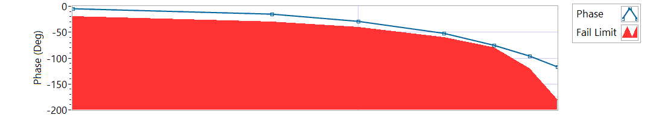

Figure - Phase for Motor Two Loaded Compression

|  |  |  |  |  |
| --- | --- | --- | --- | --- |
| **MCE 2 – Frequency response Compression** | | | | |
| **Frequency**  **(Hz)** | **Magnitude**  **(dB)** | **Phase**  **(Deg)** | **Max Phase**  **Allowance (Deg)** | **Pass/Fail** |
| 0.1 HZ | -0.310696 | -4.8744 | -20 | Pass |
| 0.5 HZ | -0.554978 | -15.498 | -30 | Pass |
| 1 HZ | -0.569564 | -28.332 | -40 | Pass |
| 2 HZ | -1.12722 | -52.272 | -60 | Pass |
| 3 HZ | -1.89124 | -74.628 | -80 | Pass |
| 4 HZ | -2.49436 | -95.904 | -120 | Pass |
| 5 HZ | -1.73566 | -116.82 | -180 | Pass |

**6.6.8.3.1 MCE 3 – Step Response Test**

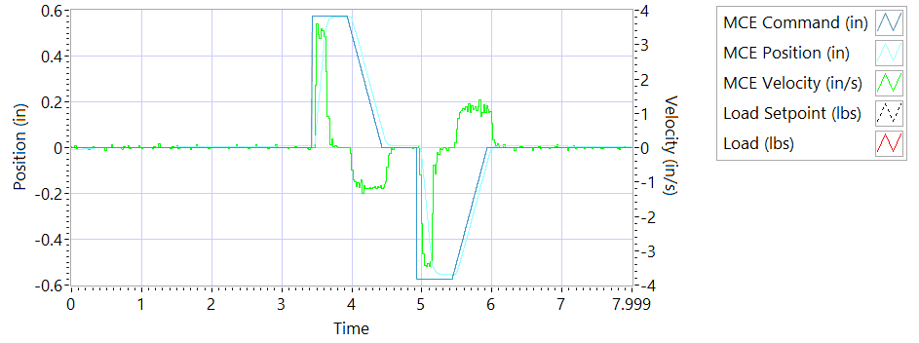

Figure - Results for Motor Three

**Step j – 225 lbf tension - Extension**

|  |  |  |  |
| --- | --- | --- | --- |
| **MCE3 – Step Response Tension Extension** | | | |
| **Requirements** | **Results** | | |
| **Description** | **Actual Speed / Time** | **Units** | **Pass/Fail** |
| No Load speed is 2.7 to 3.3 in/sec | 3.2623 | In/s | Pass |
| Time to achieve 80% of the specified stroke (+ 0.575 ins) is 170+9/-9 ms | 0.2031 | seconds | Failed |

**Step k – 225 lbf tension - Retraction**

|  |  |  |  |
| --- | --- | --- | --- |
| **MCE3 – Step Response Tension Retraction** | | | |
| **Requirements** | **Results** | | |
| **Description** | **Actual Speed / Time** | **Units** | **Pass/Fail** |
| No Load speed is 2.7 to 3.3 in/sec | -3.3065 | In/s | Pass |
| Time to achieve 80% of the specified stroke (- 0.575 ins) is 170+9/-9 ms | 0.217 | seconds | Failed |

**Step n – 225 lbf compression - Extension**

|  |  |  |  |
| --- | --- | --- | --- |
| **MCE3 – Step Response Compression Extension** | | | |
| **Requirements** | **Results** | | |
| **Description** | **Actual Speed / Time** | **Units** | **Pass/Fail** |
| No Load speed is 2.7 to 3.3 in/sec | 3.3258 | In/s | Pass |
| Time to achieve 80% of the specified stroke (+0.575 ins) is 170+9/-9 ms | 0.2131 | seconds | Failed |

**Step o – 225 lbf compression - Retraction**

|  |  |  |  |
| --- | --- | --- | --- |
| **MCE3 – Step Response Compression Retraction** | | | |
| **Requirements** | **Results** | | |
| **Description** | **Actual Speed / Time** | **Units** | **Pass/Fail** |
| No Load speed is 2.7 to 3.3 in/sec | -3.2318 | In/s | Pass |
| Time to achieve 80% of the specified stroke (-0.575 ins) is 170+9/-9 ms | 0.1919 | seconds | Failed |

**6.6.8.3.2 MCE 3 – Frequency Response Test**

**Step d – 225 lbf Tension**

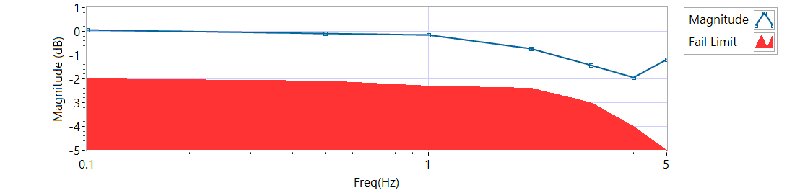

Figure - Magnitude for Motor Three Loaded Tension

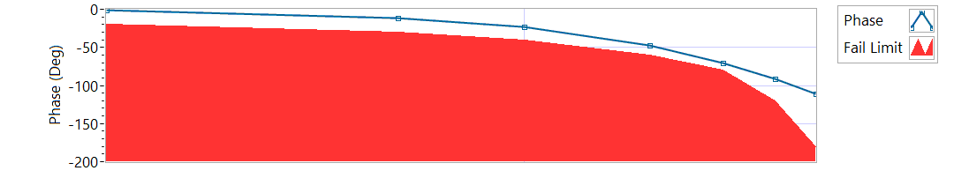

Figure - Phase for Motor Three Loaded Tension

|  |  |  |  |  |
| --- | --- | --- | --- | --- |
| **MCE 3 – Tension Frequency Response** | | | | |
| **Frequency**  **(Hz)** | **Magnitude**  **(dB)** | **Phase**  **(Deg)** | **Max Phase**  **Allowance (Deg)** | **Pass/Fail** |
| 0.1 HZ | 0.0501132 | -1.3824 | -20 | Pass |
| 0.5 HZ | -0.086894 | -11.142 | -30 | Pass |
| 1 HZ | -0.142306 | -23.58 | -40 | Pass |
| 2 HZ | -0.716787 | -47.592 | -60 | Pass |
| 3 HZ | -1.41193 | -70.524 | -80 | Pass |
| 4 HZ | -1.93535 | -91.728 | -120 | Pass |
| 5 HZ | -1.17364 | -111.42 | -180 | Pass |

**Step h – 225 lbf Compression**

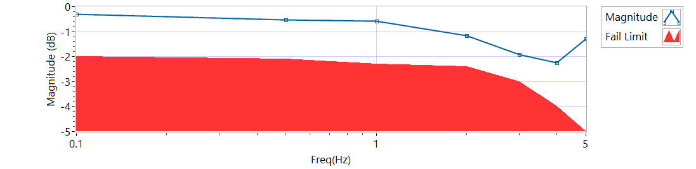

Figure - Magnitude for Motor Three Loaded Compression

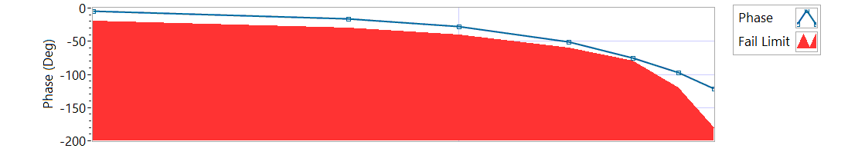

Figure - Phase for Motor Three Loaded Compression

|  |  |  |  |  |
| --- | --- | --- | --- | --- |
| **MCE 3 – Compression Frequency Response** | | | | |
| **Frequency**  **(Hz)** | **Magnitude**  **(dB)** | **Phase**  **(Deg)** | **Max Phase**  **Allowance (Deg)** | **Pass/Fail** |
| 0.1 HZ | -0.310696 | -4.9284 | -20 | Pass |
| 0.5 HZ | -0.52588 | -15.678 | -30 | Pass |
| 1 HZ | -0.569564 | -27.972 | -40 | Pass |
| 2 HZ | -1.17405 | -51.408 | -60 | Pass |
| 3 HZ | -1.9084 | -75.708 | -80 | Pass |
| 4 HZ | -2.25217 | -97.488 | -120 | Pass |
| 5 HZ | -1.28393 | -121.14 | -180 | Pass |

**6.6.9 Backlash**

6.6.9.1 **Simplex Brake 1 – ON; Duplex brake 2 – OFF**

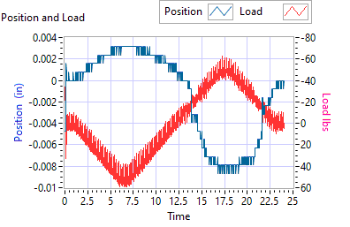

Figure - Backlash Simplex brake 1 On, Duplex brake 2 Off

|  |  |  |  |  |  |
| --- | --- | --- | --- | --- | --- |
| **Simplex Brake 1 – ON; Duplex brake 2 – OFF** | | | | | |
| **Requirements** | | | **Results** | | |
| **Step** | **Expected** | **Tolerance** | **Actual** | **Units** | **Pass/Fail** |
| Step e +/- 35 lbf tension (motor 2 and motor 3 ZERO position) | 0.0144 | 0.005 | 0.0031 | in | Pass |
| 35 | 5 | 55.3262 | lbf | Pass |
| Step e +/- 25 lbf compression (motor 2 and motor 3 ZERO position) | 0.0144 | 0.005 | -0.0087 | in | Pass |
| 35 | 5 | -53.1782 | lbf | Pass |

6.6.9.2**Simplex Brake 1 – OFF; Duplex Brake 2 – ON**

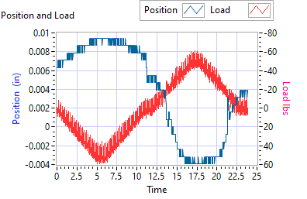

Figure - Backlash Simplex brake 1 Off, Duplex brake 2 On

|  |  |  |  |  |  |
| --- | --- | --- | --- | --- | --- |
| **Simplex Brake 1 – OFF; Duplex Brake 2 – ON** | | | | | |
| **Requirements** | | | **Results** | | |
| **Step** | **Expected** | **Tolerance** | **Actual** | **Units** | **Pass/Fail** |
| Step e +/- 35 lbf tension  (motor 1 ZERO position) | 0.0144 | 0.005 | 0.0094 | in | Pass |
| 35 | 5 | 53.0207 | lbf | Pass |
| Step e +/- 35 lbf compression  (motor 1 ZERO position) | 0.0144 | 0.005 | -0.0039 | in | Pass |
| 35 | 5 | -44.5068 | lbf | Pass |

6.6.9.3 **Both Brakes OFF**

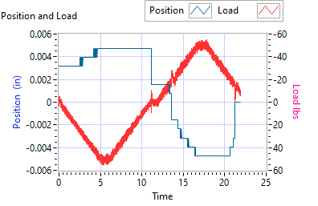

Figure - Backlash Simplex brake 1 Off, Duplex brake 2 Off

|  |  |  |  |  |  |
| --- | --- | --- | --- | --- | --- |
| **Both Brakes OFF** | | | | | |
| **Requirements** | | | **Results** | | |
| **Step** | **Expected** | **Tolerance** | **Actual** | **Units** | **Pass/Fail** |
| Step e +/- 35 lbf tension  (motor 1 and motor 2 holding ZERO position) | 0.0144 | 0.005 | 0.0047 | in | Pass |
| 35 | 5 | 51.4472 | lbf | Pass |
| Step e +/- 35 lbf compression  (motor 1 and motor 2 holding ZERO position) | 0.0144 | 0.005 | -0.0047 | in | Pass |
| 35 | 5 | -52.2139 | lbf | Pass |